**PANTALLA EJECUTAR**

1. Si se procesa el script de borrado de la tabla AAA, al ejecutar lo hace correctamente y genera físicamente el fichero con el log pero no envía en contenido del fichero de log a la lógica y está devuelve error. En la traza se puede ver cómo ha generado log (en verde) y si se entra en el fichero de log se ve que tiene contenido (en amarillo):

1:51:07.292 [AWT-EventQueue-0] INFO c.m.b.service.impl.ScriptServiceImpl - [ScriptService.executeScriptFile] Inicio Ejecucion fichero: C:\MDSQL_JAVA\scripts\pruebaEscriptTablaAAA\Lanza_20221125_11_51_MDSQL_SMD_DD_DEL.sql

11:51:07.526 [AWT-EventQueue-0] INFO c.m.b.service.impl.ScriptServiceImpl -

11:51:07.526 [AWT-EventQueue-0] INFO c.m.b.service.impl.ScriptServiceImpl - SQL*Plus: Release 11.2.0.1.0 Production on Vie Nov 25 11:51:07 2022

11:51:07.526 [AWT-EventQueue-0] INFO c.m.b.service.impl.ScriptServiceImpl -

11:51:07.526 [AWT-EventQueue-0] INFO c.m.b.service.impl.ScriptServiceImpl - Copyright (c) 1982, 2010, Oracle. All rights reserved.

11:51:07.526 [AWT-EventQueue-0] INFO c.m.b.service.impl.ScriptServiceImpl -

11:51:07.776 [AWT-EventQueue-0] INFO c.m.b.service.impl.ScriptServiceImpl -

11:51:07.792 [AWT-EventQueue-0] INFO c.m.b.service.impl.ScriptServiceImpl - Conectado a:

11:51:07.792 [AWT-EventQueue-0] INFO c.m.b.service.impl.ScriptServiceImpl - Oracle Database 19c Enterprise Edition Release 19.0.0.0.0 - Production

11:51:07.792 [AWT-EventQueue-0] INFO c.m.b.service.impl.ScriptServiceImpl -

11:51:07.807 [AWT-EventQueue-0] INFO c.m.b.service.impl.ScriptServiceImpl - -- EL SIGUIENTE DROP FALLAR├? SI EL OBJETO NO EXISTE. NO ES UN ERROR

11:51:07.807 [AWT-EventQueue-0] INFO c.m.b.service.impl.ScriptServiceImpl - antiguo 1: DROP TABLE &&USROWN._LD.AAA

11:51:07.807 [AWT-EventQueue-0] INFO c.m.b.service.impl.ScriptServiceImpl - nuevo 1: DROP TABLE SMD_LD.AAA

11:51:08.624 [AWT-EventQueue-0] INFO c.m.b.service.impl.ScriptServiceImpl -

11:51:08.626 [AWT-EventQueue-0] INFO c.m.b.service.impl.ScriptServiceImpl - Tabla borrada.

11:51:08.629 [AWT-EventQueue-0] INFO c.m.b.service.impl.ScriptServiceImpl -

11:51:08.640 [AWT-EventQueue-0] INFO c.m.b.service.impl.ScriptServiceImpl - Desconectado de Oracle Database 19c Enterprise Edition Release 19.0.0.0.0 - Production

11:51:08.665 [AWT-EventQueue-0] INFO c.m.b.service.impl.ScriptServiceImpl - [ScriptService.executeScriptFile] Fin Ejecucion exitCode: 0

11:51:08.667 [AWT-EventQueue-0] INFO c.m.b.service.impl.ServiceSupport - {call SM2_K_LD_MDSQL_MARIPAM.P_REGISTRA_EJECUCION(?,?,?,?,?,?,?,?,?,?,?,?,?)}

11:51:08.668 [AWT-EventQueue-0] INFO c.m.b.service.impl.ServiceSupport - Parßmetros de entrada:

399

1

MARIPAM

[]

1. Si desmarco todos los scripts y marco el primero, me marca los siguientes. Esto no debe pasar. Cuando selecciono un script para ejecutar debe marcar los scripts NO EJECUTADOS anteriores, no los posteriores.
2. Procesamos un script y ejecutamos forzando el error. Da el error correctamente y vemos que ha generado los ficheros SQL, Log y Lanza

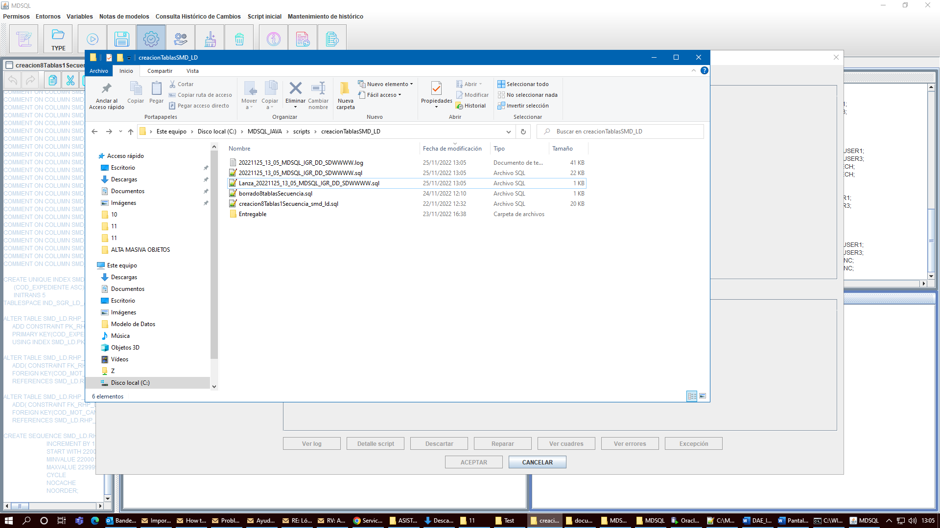

Rechazamos el procesado y vemos que borra el lanza correctamente pero no renombra los ficheros tal como se indica en el documento. En concreto:

*Se renombrarán los ficheros generados (incluidos los log si se hubiese ejecutado algún fichero, si los hubiese), incluyendo antes de la extensión el literal almacenado en los parámetros de configuración SufijoRechazoProcesado*

El valor de ese parámetro lo tenemos a RECHAZADO.

1. Si un script ha dado error, al seleccionar el script se habilita el botón de Detalle Script. Si se pulsa se abre la pantalla de ver detalle. Ampliar el tamaño inicial (tranquilamente el doble de alto). Al abrirse se muestra así:

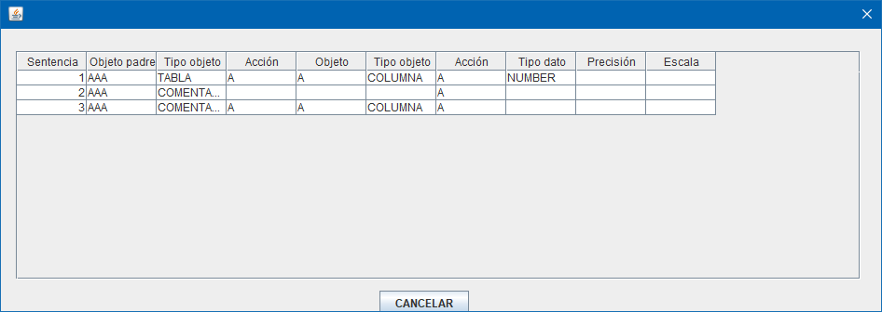

1. Si un script ha dado error, al seleccionar el script se habilita el botón de Ver Log. Si se pulsa no hace nada.
2. Se procesa un script (con 8 tablas) que genera dos ficheros (SQL y PDC). Se desmarca el PDC para que solo ejecute el primer script. El script se ejecuta correctamente. Al seleccionarlo se habilita el botón de Ver cuadres. Si lo pulsas se produce el siguiente error:

11:49:42.175 [AWT-EventQueue-0] INFO c.m.b.service.impl.ServiceSupport - {call SM2_K_LD_MDSQL_MARIPAM.P_CON_CUADRE_OBJ_SCRIPT(?,?,?,?,?)}

11:49:42.175 [AWT-EventQueue-0] INFO c.m.b.service.impl.ServiceSupport - Parßmetros de entrada:

392

1

Exception in thread "AWT-EventQueue-0" java.lang.ClassCastException: java.lang.String cannot be cast to java.math.BigDecimal

at com.mdsql.bussiness.service.impl.CuadreServiceImpl.consultaCuadreOperacionesObjetoScript(CuadreServiceImpl.java:124)

at com.mdsql.ui.listener.PantallaVerCuadresScriptListener.onLoad(PantallaVerCuadresScriptListener.java:56)

at com.mdval.ui.utils.DialogSupport.initialize(DialogSupport.java:100)

at com.mdval.ui.utils.DialogSupport.<init>(DialogSupport.java:77)

at com.mdsql.ui.PantallaVerCuadresScript.<init>(PantallaVerCuadresScript.java:57)

at com.mdsql.ui.utils.creators.DialogCreator.factoryMethod(DialogCreator.java:102)

at com.mdsql.ui.utils.MDSQLUIHelper.createDialog(MDSQLUIHelper.java:41)

at com.mdsql.ui.listener.PantallaEjecutarScriptsListener.eventBtnVerCuadres(PantallaEjecutarScriptsListener.java:159)

at com.mdsql.ui.listener.PantallaEjecutarScriptsListener.actionPerformed(PantallaEjecutarScriptsListener.java:75)

at javax.swing.AbstractButton.fireActionPerformed(Unknown Source)

at javax.swing.AbstractButton$Handler.actionPerformed(Unknown Source)

at javax.swing.DefaultButtonModel.fireActionPerformed(Unknown Source)

at javax.swing.DefaultButtonModel.setPressed(Unknown Source)

at javax.swing.plaf.basic.BasicButtonListener.mouseReleased(Unknown Source)

at java.awt.Component.processMouseEvent(Unknown Source)

at javax.swing.JComponent.processMouseEvent(Unknown Source)

at java.awt.Component.processEvent(Unknown Source)

at java.awt.Container.processEvent(Unknown Source)

at java.awt.Component.dispatchEventImpl(Unknown Source)

at java.awt.Container.dispatchEventImpl(Unknown Source)

at java.awt.Component.dispatchEvent(Unknown Source)

at java.awt.LightweightDispatcher.retargetMouseEvent(Unknown Source)

at java.awt.LightweightDispatcher.processMouseEvent(Unknown Source)

at java.awt.LightweightDispatcher.dispatchEvent(Unknown Source)

at java.awt.Container.dispatchEventImpl(Unknown Source)

at java.awt.Window.dispatchEventImpl(Unknown Source)

at java.awt.Component.dispatchEvent(Unknown Source)

at java.awt.EventQueue.dispatchEventImpl(Unknown Source)

at java.awt.EventQueue.access$500(Unknown Source)

at java.awt.EventQueue$3.run(Unknown Source)

at java.awt.EventQueue$3.run(Unknown Source)

at java.security.AccessController.doPrivileged(Native Method)

at java.security.ProtectionDomain$JavaSecurityAccessImpl.doIntersectionPrivilege(Unknown Source)

at java.security.ProtectionDomain$JavaSecurityAccessImpl.doIntersectionPrivilege(Unknown Source)

at java.awt.EventQueue$4.run(Unknown Source)

at java.awt.EventQueue$4.run(Unknown Source)

at java.security.AccessController.doPrivileged(Native Method)

at java.security.ProtectionDomain$JavaSecurityAccessImpl.doIntersectionPrivilege(Unknown Source)

at java.awt.EventQueue.dispatchEvent(Unknown Source)

at java.awt.EventDispatchThread.pumpOneEventForFilters(Unknown Source)

at java.awt.EventDispatchThread.pumpEventsForFilter(Unknown Source)

at java.awt.EventDispatchThread.pumpEventsForFilter(Unknown Source)

at java.awt.WaitDispatchSupport$2.run(Unknown Source)

at java.awt.WaitDispatchSupport$4.run(Unknown Source)

at java.awt.WaitDispatchSupport$4.run(Unknown Source)

at java.security.AccessController.doPrivileged(Native Method)

at java.awt.WaitDispatchSupport.enter(Unknown Source)

at java.awt.Dialog.show(Unknown Source)

at java.awt.Component.show(Unknown Source)

at java.awt.Component.setVisible(Unknown Source)

at java.awt.Window.setVisible(Unknown Source)

at java.awt.Dialog.setVisible(Unknown Source)

at com.mdval.ui.utils.UIHelper.show(UIHelper.java:63)

at com.mdsql.ui.listener.FramePrincipalActionListener.evtEjecutar(FramePrincipalActionListener.java:354)

at com.mdsql.ui.listener.FramePrincipalActionListener.actionPerformed(FramePrincipalActionListener.java:96)

at javax.swing.AbstractButton.fireActionPerformed(Unknown Source)

at javax.swing.AbstractButton$Handler.actionPerformed(Unknown Source)

at javax.swing.DefaultButtonModel.fireActionPerformed(Unknown Source)

at javax.swing.DefaultButtonModel.setPressed(Unknown Source)

at javax.swing.plaf.basic.BasicButtonListener.mouseReleased(Unknown Source)

at java.awt.AWTEventMulticaster.mouseReleased(Unknown Source)

at java.awt.Component.processMouseEvent(Unknown Source)

at javax.swing.JComponent.processMouseEvent(Unknown Source)

at java.awt.Component.processEvent(Unknown Source)

at java.awt.Container.processEvent(Unknown Source)

at java.awt.Component.dispatchEventImpl(Unknown Source)

at java.awt.Container.dispatchEventImpl(Unknown Source)

at java.awt.Component.dispatchEvent(Unknown Source)

at java.awt.LightweightDispatcher.retargetMouseEvent(Unknown Source)

at java.awt.LightweightDispatcher.processMouseEvent(Unknown Source)

at java.awt.LightweightDispatcher.dispatchEvent(Unknown Source)

at java.awt.Container.dispatchEventImpl(Unknown Source)

at java.awt.Window.dispatchEventImpl(Unknown Source)

at java.awt.Component.dispatchEvent(Unknown Source)

at java.awt.EventQueue.dispatchEventImpl(Unknown Source)

at java.awt.EventQueue.access$500(Unknown Source)

at java.awt.EventQueue$3.run(Unknown Source)

at java.awt.EventQueue$3.run(Unknown Source)

at java.security.AccessController.doPrivileged(Native Method)

at java.security.ProtectionDomain$JavaSecurityAccessImpl.doIntersectionPrivilege(Unknown Source)

at java.security.ProtectionDomain$JavaSecurityAccessImpl.doIntersectionPrivilege(Unknown Source)

at java.awt.EventQueue$4.run(Unknown Source)

at java.awt.EventQueue$4.run(Unknown Source)

at java.security.AccessController.doPrivileged(Native Method)

at java.security.ProtectionDomain$JavaSecurityAccessImpl.doIntersectionPrivilege(Unknown Source)

at java.awt.EventQueue.dispatchEvent(Unknown Source)

at java.awt.EventDispatchThread.pumpOneEventForFilters(Unknown Source)

at java.awt.EventDispatchThread.pumpEventsForFilter(Unknown Source)

at java.awt.EventDispatchThread.pumpEventsForHierarchy(Unknown Source)

at java.awt.EventDispatchThread.pumpEvents(Unknown Source)

at java.awt.EventDispatchThread.pumpEvents(Unknown Source)

at java.awt.EventDispatchThread.run(Unknown Source)

1. Pese a haber finalizado la ejecución de un fichero, parece que la aplicación sigue teniendo abiertos los ficheros de log. Si se intentan borrar se produce este error:

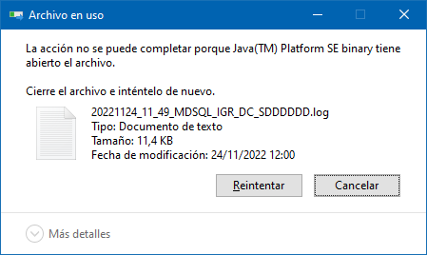

1. Volvemos a procesar un script que genera dos ficheros. Ejecutamos el primero sin errores. Actualiza sus datos en el listado. Ejecutamos el segundo sin errores y nos redirige a la pantalla de resumen. Pulsamos entregar y se produce un error:

12:22:16.701 [AWT-EventQueue-0] INFO c.m.u.l.PantallaResumenProcesadoActionListener - Zip file name: \\Nes011901-007\modelodatos\TEMPORAL_PUESTOS_VIRTUALES\MARIPAM\MDSQL_JAVA\pruebas\MDSQL_IGR\20221124_12_18_MDSQL_IGR_DD_SDFFFFF.zip

12:22:16.785 [AWT-EventQueue-0] INFO c.m.u.l.PantallaResumenProcesadoActionListener - Ruta entregados: C:\MDSQL_JAVA\scripts\creacionTablasSMD_LD\Entregable

12:22:16.790 [AWT-EventQueue-0] ERROR c.m.u.l.PantallaResumenProcesadoActionListener - \\Nes011901-007\modelodatos\TEMPORAL_PUESTOS_VIRTUALES\MARIPAM\MDSQL_JAVA\pruebas\MDSQL_IGR\20221124_12_18_MDSQL_IGR_DD_SDFFFFF.zip -> C:\MDSQL_JAVA\scripts\creacionTablasSMD_LD\Entregable\20221124_12_18_MDSQL_IGR_DD_SDFFFFF.zip

12:22:16.790 [AWT-EventQueue-0] ERROR c.m.u.l.PantallaResumenProcesadoActionListener - C:\MDSQL_JAVA\scripts\creacionTablasSMD_LD\20221124_12_18_MDSQL_IGR_DD_SDFFFFF.sql -> C:\MDSQL_JAVA\scripts\creacionTablasSMD_LD\Entregable\20221124_12_18_MDSQL_IGR_DD_SDFFFFF.sql

12:22:16.791 [AWT-EventQueue-0] ERROR c.m.u.l.PantallaResumenProcesadoActionListener - C:\MDSQL_JAVA\scripts\creacionTablasSMD_LD\20221124_12_18_MDSQL_IGR_DC_SDFFFFF.pdc -> C:\MDSQL_JAVA\scripts\creacionTablasSMD_LD\Entregable\20221124_12_18_MDSQL_IGR_DC_SDFFFFF.pdc

12:22:16.792 [AWT-EventQueue-0] INFO c.m.b.service.impl.ServiceSupport - {call SM2_K_LD_MDSQL_MARIPAM.P_ENTREGAR_PETICION(?,?,?,?,?,?)}

12:22:16.794 [AWT-EventQueue-0] INFO c.m.b.service.impl.ServiceSupport - Parßmetros de entrada:

394

MARIPAM

NULL

Exception in thread "AWT-EventQueue-0" java.security.PrivilegedActionException: java.security.PrivilegedActionException: com.mdval.exceptions.ServiceException

at java.security.AccessController.doPrivileged(Native Method)

at java.security.ProtectionDomain$JavaSecurityAccessImpl.doIntersectionPrivilege(Unknown Source)

at java.awt.EventQueue.dispatchEvent(Unknown Source)

at java.awt.EventDispatchThread.pumpOneEventForFilters(Unknown Source)

at java.awt.EventDispatchThread.pumpEventsForFilter(Unknown Source)

at java.awt.EventDispatchThread.pumpEventsForFilter(Unknown Source)

at java.awt.WaitDispatchSupport$2.run(Unknown Source)

at java.awt.WaitDispatchSupport$4.run(Unknown Source)

at java.awt.WaitDispatchSupport$4.run(Unknown Source)

at java.security.AccessController.doPrivileged(Native Method)

at java.awt.WaitDispatchSupport.enter(Unknown Source)

at java.awt.Dialog.show(Unknown Source)

at java.awt.Component.show(Unknown Source)

at java.awt.Component.setVisible(Unknown Source)

at java.awt.Window.setVisible(Unknown Source)

at java.awt.Dialog.setVisible(Unknown Source)

at com.mdval.ui.utils.UIHelper.show(UIHelper.java:63)

at com.mdsql.ui.listener.FramePrincipalActionListener.evtEjecutar(FramePrincipalActionListener.java:379)

at com.mdsql.ui.listener.FramePrincipalActionListener.actionPerformed(FramePrincipalActionListener.java:96)

at javax.swing.AbstractButton.fireActionPerformed(Unknown Source)

at javax.swing.AbstractButton$Handler.actionPerformed(Unknown Source)

at javax.swing.DefaultButtonModel.fireActionPerformed(Unknown Source)

at javax.swing.DefaultButtonModel.setPressed(Unknown Source)

at javax.swing.plaf.basic.BasicButtonListener.mouseReleased(Unknown Source)

at java.awt.AWTEventMulticaster.mouseReleased(Unknown Source)

at java.awt.Component.processMouseEvent(Unknown Source)

at javax.swing.JComponent.processMouseEvent(Unknown Source)

at java.awt.Component.processEvent(Unknown Source)

at java.awt.Container.processEvent(Unknown Source)

at java.awt.Component.dispatchEventImpl(Unknown Source)

at java.awt.Container.dispatchEventImpl(Unknown Source)

at java.awt.Component.dispatchEvent(Unknown Source)

at java.awt.LightweightDispatcher.retargetMouseEvent(Unknown Source)

at java.awt.LightweightDispatcher.processMouseEvent(Unknown Source)

at java.awt.LightweightDispatcher.dispatchEvent(Unknown Source)

at java.awt.Container.dispatchEventImpl(Unknown Source)

at java.awt.Window.dispatchEventImpl(Unknown Source)

at java.awt.Component.dispatchEvent(Unknown Source)

at java.awt.EventQueue.dispatchEventImpl(Unknown Source)

at java.awt.EventQueue.access$500(Unknown Source)

at java.awt.EventQueue$3.run(Unknown Source)

at java.awt.EventQueue$3.run(Unknown Source)

at java.security.AccessController.doPrivileged(Native Method)

at java.security.ProtectionDomain$JavaSecurityAccessImpl.doIntersectionPrivilege(Unknown Source)

at java.security.ProtectionDomain$JavaSecurityAccessImpl.doIntersectionPrivilege(Unknown Source)

at java.awt.EventQueue$4.run(Unknown Source)

at java.awt.EventQueue$4.run(Unknown Source)

at java.security.AccessController.doPrivileged(Native Method)

at java.security.ProtectionDomain$JavaSecurityAccessImpl.doIntersectionPrivilege(Unknown Source)

at java.awt.EventQueue.dispatchEvent(Unknown Source)

at java.awt.EventDispatchThread.pumpOneEventForFilters(Unknown Source)

at java.awt.EventDispatchThread.pumpEventsForFilter(Unknown Source)

at java.awt.EventDispatchThread.pumpEventsForHierarchy(Unknown Source)

at java.awt.EventDispatchThread.pumpEvents(Unknown Source)

at java.awt.EventDispatchThread.pumpEvents(Unknown Source)

at java.awt.EventDispatchThread.run(Unknown Source)

Caused by: java.security.PrivilegedActionException: com.mdval.exceptions.ServiceException

at java.security.AccessController.doPrivileged(Native Method)

at java.security.ProtectionDomain$JavaSecurityAccessImpl.doIntersectionPrivilege(Unknown Source)

at java.security.ProtectionDomain$JavaSecurityAccessImpl.doIntersectionPrivilege(Unknown Source)

at java.awt.EventQueue$4.run(Unknown Source)

at java.awt.EventQueue$4.run(Unknown Source)

... 56 more

Caused by: com.mdval.exceptions.ServiceException

at com.mdsql.bussiness.service.impl.ServiceSupport.buildException(ServiceSupport.java:64)

at com.mdsql.bussiness.service.impl.ServiceSupport.buildException(ServiceSupport.java:46)

at com.mdsql.bussiness.service.impl.EntregaServiceImpl.entregarPeticion(EntregaServiceImpl.java:112)

at com.mdsql.ui.listener.PantallaResumenProcesadoActionListener.evtEntregar(PantallaResumenProcesadoActionListener.java:103)

at com.mdsql.ui.listener.PantallaResumenProcesadoActionListener.actionPerformed(PantallaResumenProcesadoActionListener.java:65)

at javax.swing.AbstractButton.fireActionPerformed(Unknown Source)

at javax.swing.AbstractButton$Handler.actionPerformed(Unknown Source)

at javax.swing.DefaultButtonModel.fireActionPerformed(Unknown Source)

at javax.swing.DefaultButtonModel.setPressed(Unknown Source)

at javax.swing.plaf.basic.BasicButtonListener.mouseReleased(Unknown Source)

at java.awt.Component.processMouseEvent(Unknown Source)

at javax.swing.JComponent.processMouseEvent(Unknown Source)

at java.awt.Component.processEvent(Unknown Source)

at java.awt.Container.processEvent(Unknown Source)

at java.awt.Component.dispatchEventImpl(Unknown Source)

at java.awt.Container.dispatchEventImpl(Unknown Source)

at java.awt.Component.dispatchEvent(Unknown Source)

at java.awt.LightweightDispatcher.retargetMouseEvent(Unknown Source)

at java.awt.LightweightDispatcher.processMouseEvent(Unknown Source)

at java.awt.LightweightDispatcher.dispatchEvent(Unknown Source)

at java.awt.Container.dispatchEventImpl(Unknown Source)

at java.awt.Window.dispatchEventImpl(Unknown Source)

at java.awt.Component.dispatchEvent(Unknown Source)

at java.awt.EventQueue.dispatchEventImpl(Unknown Source)

at java.awt.EventQueue.access$500(Unknown Source)

at java.awt.EventQueue$3.run(Unknown Source)

at java.awt.EventQueue$3.run(Unknown Source)

... 61 more

El fichero ZIP lo ha creado en la ruta que indica el log:

\\Nes011901-007\modelodatos\TEMPORAL_PUESTOS_VIRTUALES\MARIPAM\MDSQL_JAVA\pruebas\MDSQL_IGR\20221124_12_18_MDSQL_IGR_DD_SDFFFFF.zip

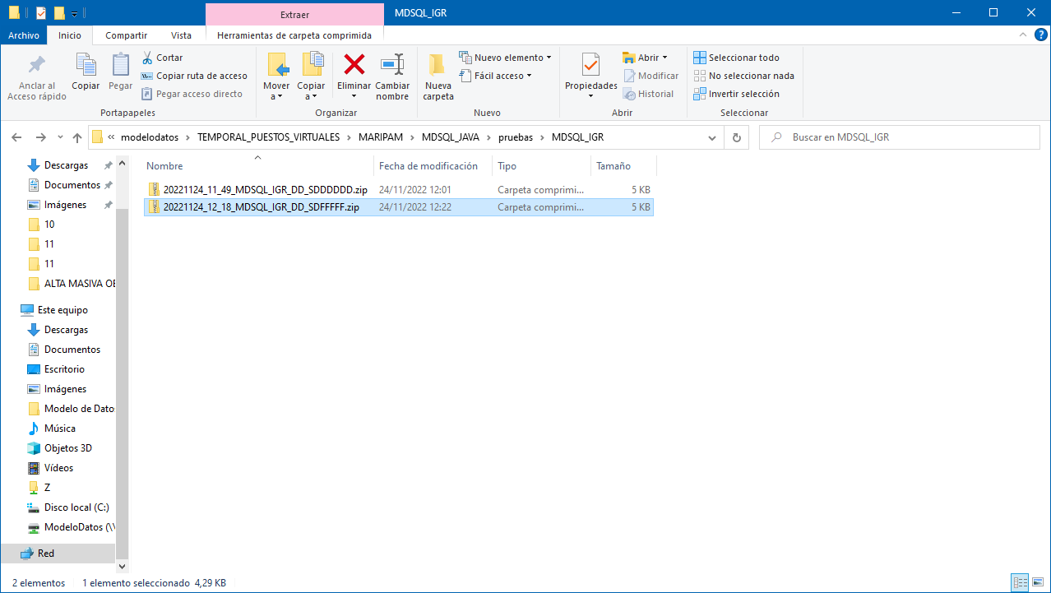

El error se ha producido al no incluir un comentario. Este campo es controlado por la lógica de negocio y cuando no está informado devuelve un error de negocio que hay que mostrar por pantalla. Si se incluye, funciona correctamente y entrega el procesado.